**Design and implementation of a new lightweight chaos-based cryptosystem to secure IoT communications.**

Roll: 1807021 Date: 14/05/2023

**Recap:** Previously I read and grasped the contents of the entire paper. Learnt about proposed cryptosystem in detail to understand the said encryption and decryption process.

**My Work:** Lorenz system is used for random generator part in this paper. Below is the equation:

$$\frac{d z(t)}{dt}=xy-bz$$

$$\frac{d y(t)}{dt}=cx-y-xz$$

$\frac{d x\left(t\right)}{dt}=a\left(y-x\right)$

Here a, b and c are the system parameters and x0, y0 and z0 are the initial conditions. Runge-Kutta method is used to solve this equation. It is simulated in MATLAB tool.

Attractors: Set of points in the phase space of a dynamic system which attracts all the trajectories in the area surrounding it – known as the basin of attraction. It’s a fixed point attractor.

Lorenz attractors - Strange: Meteorologist Edward Lorenz, in 1963, when developing a simulation, simplified equations as above. It describes “convection cycle” and known as Lorenz system.

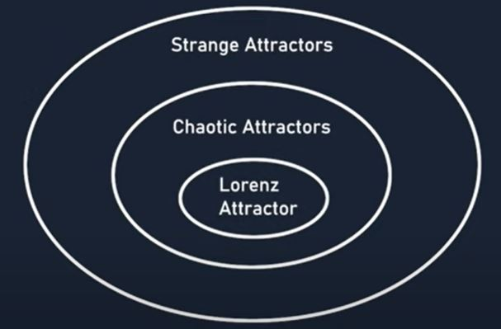Strange attractor: Attractor that has a fractal structure. No point in the space is ever visited more than once by the same trajectory. So the trajectory travel in predictable loop. Consequently this space has non-integer dimension. Its dimension is about 2.06. It contains detail at arbitrarily small scales. Lorenz attractor is a fractal space and hence a strange attractor.

**Future Plan:** Learn more detail about Lonrenz system and also simulate it in MATLAB tool.